Morning Checklist
Code:
from airflow.sdk import dag, task
from airflow import DAG
from airflow.operators.python import PythonOperator, BranchPythonOperator
from airflow.operators.bash import BashOperator
from datetime import datetime, timedelta

def count_tickets():
import random
count=random.randint(0, 20)
print(f"Overnight tickets: {count}")
return count
def check_workload(**context):
if context['ti'].xcom_pull(task_ids='count_tickets') >= 10:
print("High workload detected → Prioritizing urgent tasks")
return 'busy_day'
else:
print("Workload manageable → Proceeding with regular tasks")
return 'quiet_day'
def busy_day():
print("BUSY DAY — calling in extra support staff.")
def quiet_day():
print("QUIET DAY — normal staffing today.")
def daily_summary():
print("Morning checklist complete. Have a good day!")

with DAG(
dag_id="morning_checklist",
schedule="@daily",
start_date=datetime(2026, 1, 1),
catchup=False
)as dag:

system_check =BashOperator(
task_id="system_check",
bash_command="echo 'Office system check — all OK' && date"
)

count_tickets=PythonOperator(
task_id="count_tickets",
python_callable=count_tickets
)

check_workload=BranchPythonOperator(
task_id="check_workload",
python_callable=check_workload
# provide_context=True
)

busy_day=PythonOperator(
task_id="busy_day",
python_callable=busy_day
)

quiet_day=PythonOperator(
task_id="quiet_day",
python_callable=quiet_day
)

daily_summary=PythonOperator(
task_id="daily_summary",
python_callable=daily_summary,
trigger_rule="none_failed"
)

system_check>>count_tickets>>check_workload>>[busy_day,quiet_day]>>daily_summary

- Graph View — busy_day is GREEN, quiet_day is pink (skipped), daily_summary is GREEN
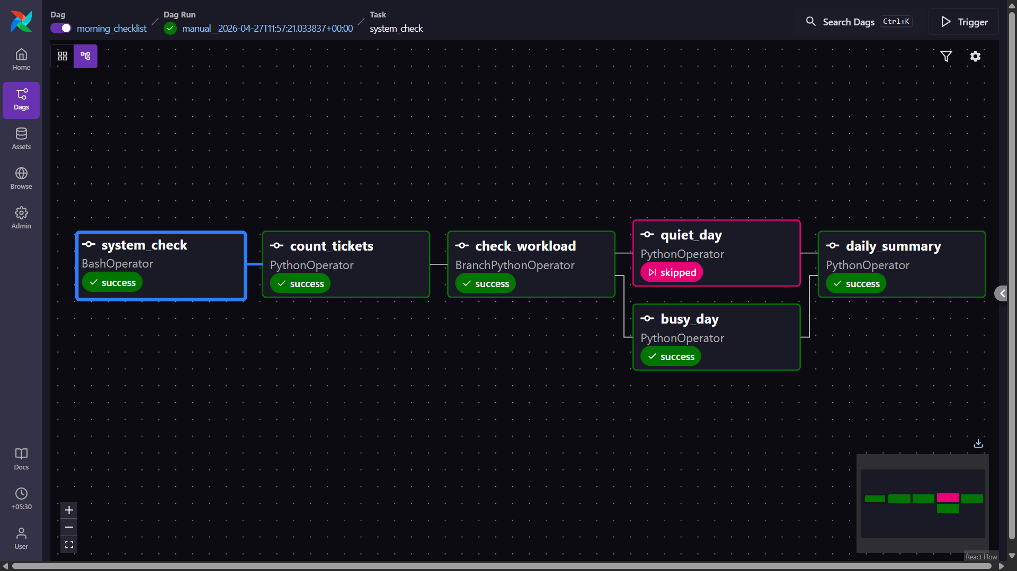
- Graph View — quiet_day is GREEN, busy_day is pink (skipped), daily_summary is GREEN
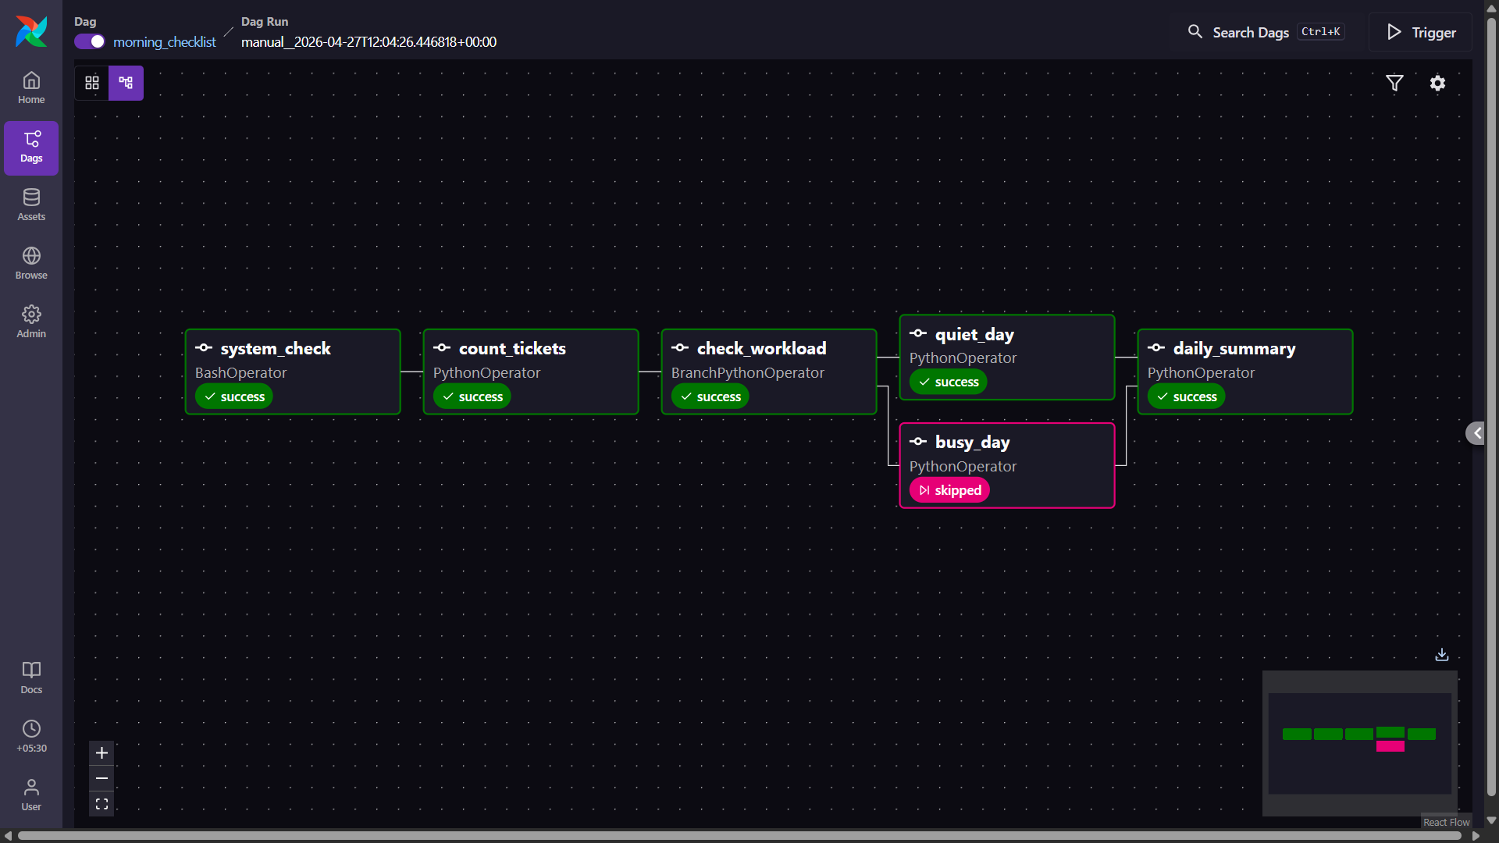

- Task Log of system_check — showing "Office system check — all OK" and the date from the bash command
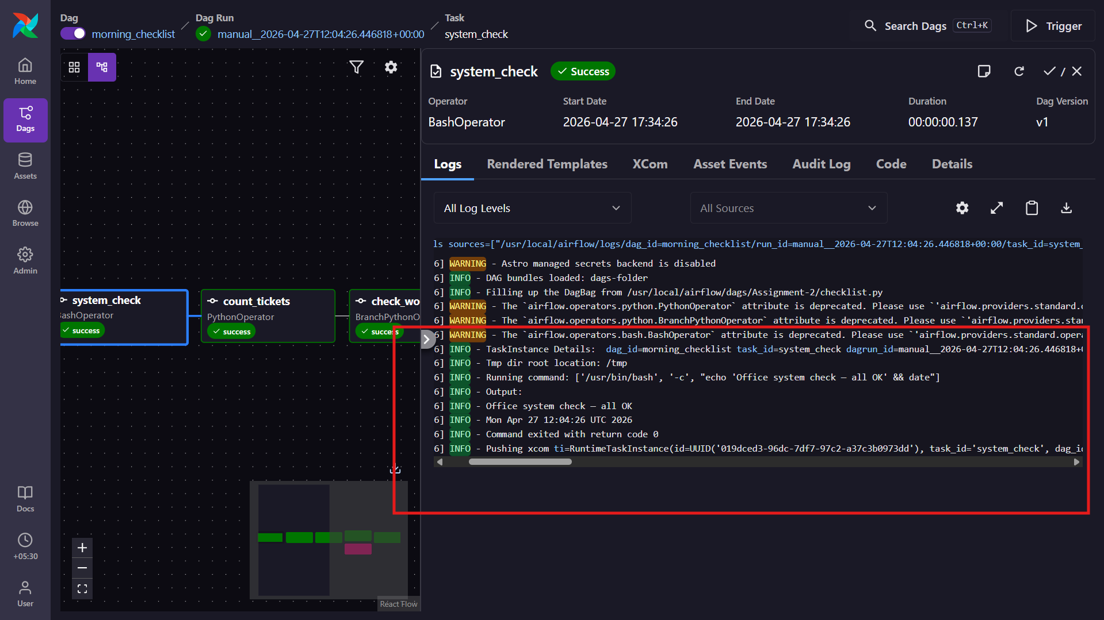4. Task Log of check_workload — showing the ticket number and the branch decision printed
